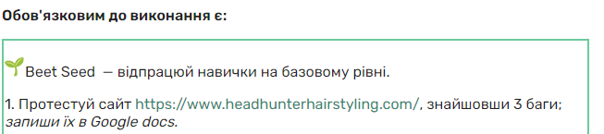

| **Operating System** | Windows 10 |
| --- | --- |
| **Device** | Desktop |
| **Bug** | Stylist's menu: clicking on the photo opens a third-party site. |
| **Link** | [https://www.headhunterhairstyling.com/stylists](https://www.headhunterhairstyling.com/) |
| **Step** | 1. Click on the stylist's photo. |
| **Expected result:** | The opening of the stylist's photo. |
| **The actual result:** | The opening of a third-party site. |
| **Photo** |  |
| **Severity** | Critical |
| **Priorities** | High |

| **Operating System** | Windows 10 |
| --- | --- |
| **Device** | Desktop |
| **Bug** | Contact form: the "Name" field should not allow entering invalid data |
| **Link** | [https://www.headhunterhairstyling.com/contact](https://www.headhunterhairstyling.com/) |
| **Step** | 1. Fill in the "Name*" field with invalid data |
| 2. Fill in the field "Email*" tanchic888@gmail.com |
| 3. Fill in the "Phone" field <+3809889999898> |
| 4. Fill in the field "Topic" <Clarification about the hairstyle> |
| 5. Fill in the "Message" field <What hair product is used to fix the hairstyle> |
| **Expected result:** | The "Name*" field is highlighted in red and an error message is displayed on the contact form, invalid data has been entered. |
| **The actual result:** | The "Name*" field after entering invalid data is highlighted as valid data. |
| **Photo** |  |
| **Severity** | Critical |
| **Priorities** | High |

| **Operating System** | Windows 10 |
| --- | --- |
| **Device** | Desktop |
| **Bug** | Home Menu: Spelling error in the logo. |
| **Link** | [https://www.headhunterhairstyling.com/contact](https://www.headhunterhairstyling.com/) |
| **Step** | 1. Read the text on the website |
| **Expected result:** | Error-free logo. |
| **The actual result:** | A logo made of bugs |
| **Photo** |  |
| **Severity** | Critical |
| **Priorities** | High |

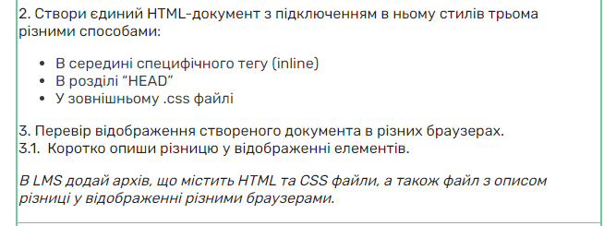

2.<https://drive.google.com/drive/folders/1E79IPQvmCHVDPNQkxczAM43MOXq6gI54?usp=sharing>

3.1 Відображення у браузері Microsoft Edge чіткіше і яскравіше ніж у Google Chrome.

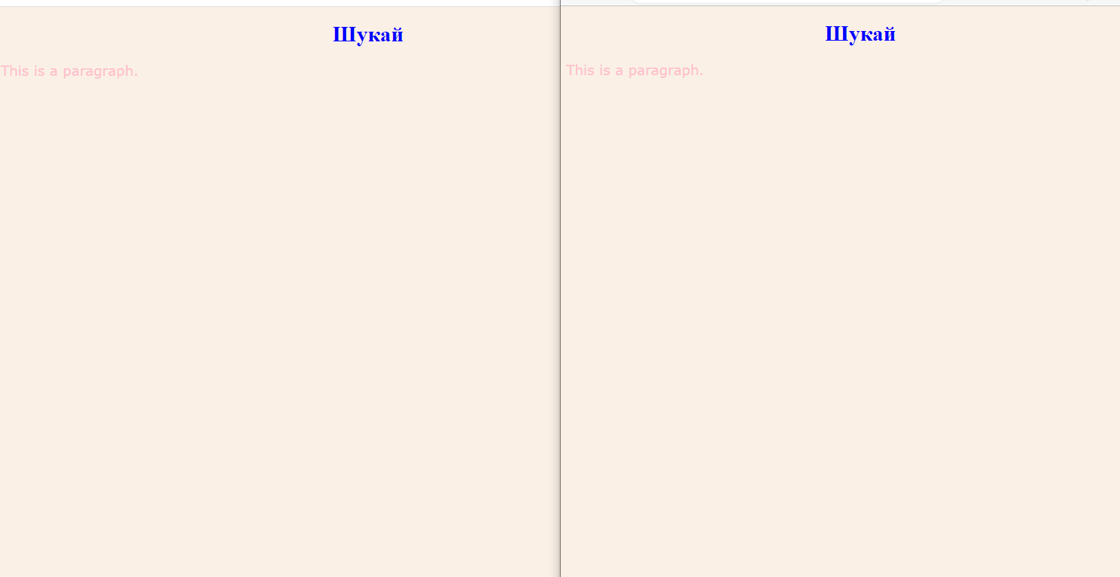

Google Chrome Microsoft Edge

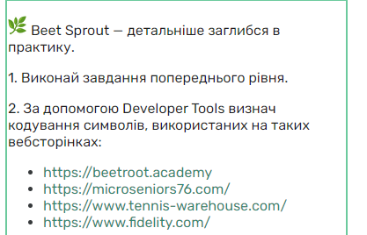

| **Лінк сайту** | **Кодування символів** |
| --- | --- |
| <https://beetroot.academy/> | <meta charset="utf-8"> |
| <https://microseniors76.com/> | <meta http-equiv="Content-Type" content="text/html; charset=iso-8859-1"> |
| <https://www.tennis-warehouse.com/> | <link type="text/css" rel="stylesheet" charset="UTF-8" href="https://www.gstatic.com/_/translate_http/_/ss/k=translate_http.tr.qhDXWpKopYk.L.W.O/d=0/rs=AN8SPfp0QXhhaDDdjg_LgcSqoZiPEzC1tw/m=el_main_css"> |
| <https://www.fidelity.com/> | <meta http-equiv="Content-Type" content="text/html; charset=iso-8859-1"> |